Grouping “stationary” features based on the motion cue

Ryusuke Hayashi and Manabu Tanifuji
RIKEN Brain Science Institute, Japan

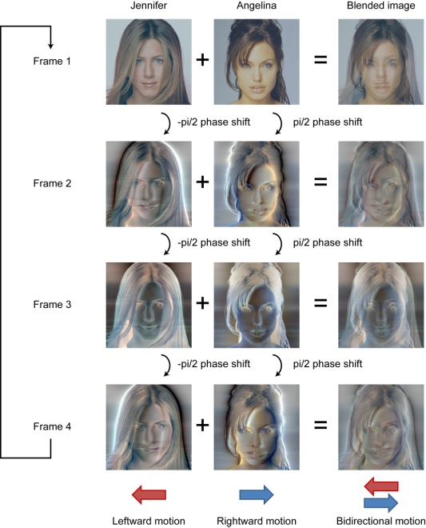
It is known that local elements tend to be grouped into the holistic and global pattern based on the Gestalt laws such as the similarity of orientation, color and so forth. Here, we developed a new motion display, which demonstrates that direction information can improve the grouping of the local features even if the grouped features per se are stationary. Let’s see the situation when the two face images are superimposed and the correct identification of individual face is disturbed by the miss-binding of the facial parts (such as the eyes, the nose, and the mouth) across the faces (Figure 1). As depicted in Figure 2, we used the image processing technique, known as quadrature motion (Carney & Shadlen, 1993), and superimposed the two face images that are perceived to move in the opposite direction. Since the motion is generated by shifting the Fourier phase of all spatial frequency components by a fixed amount every frame, the position of overall pattern information does not change. Therefore, the separation of the two faces is difficult in the same degree at each frame. Nevertheless, the segregation of the two faces is facilitated if the images are observed as a movie, presumably because the grouping of the local features was established based on the direction information (Movie 1, play at repeating mode). If the salient facial features are completely overlapped with each other, the separation of the two faces becomes unclear (Movie 2). Therefore, we consider that the direction-based grouping mechanism demonstrated here is mediated after the detection of each element (also see Movie 3).
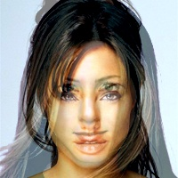

Figure 1 Figure 2

